**Course: Advanced Bioinformatics**

**Module title: Neural Networks**

**Module no. : 182**

In machine learning and cognitive science, artificial neural networks (ANNs) are a family of models inspired by biological neural networks (the central nervous systems of animals, in particular the brain) and are used to estimate or approximate functions that can depend on a large number of inputs and are generally unknown. Artificial neural networks are generally presented as systems of interconnected "neurons" which exchange messages between each other. The connections have numeric weights that can be tuned based on experience, making neural nets adaptive to inputs and capable of learning. For example, a neural network for handwriting recognition is defined by a set of input neurons which may be activated by the pixels of an input image. After being weighted and transformed by a function (determined by the network's designer), the activation of these neurons are then passed on to other neurons. This process is repeated until finally, an output neuron is activated. This determines which character was read. Like other machine learning methods - systems that learn from data - neural networks have been used to solve a wide variety of tasks that are hard to solve using ordinary rule-based programming, including computer vision and speech recognition.

* A neural network is a “connectionist” computational system
* Information is processed collectively in parallel throughout a network of nodes
* Complex adaptive system

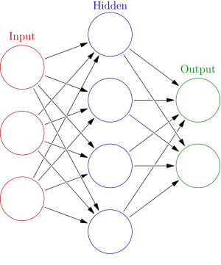

An artificial neural network is an interconnected group of nodes, akin to the vast network of neurons in a brain. Here, each circular node represents an artificial neuron and an arrow represents a connection from the output of one neuron to the input of another.